

**Disclaimer: The content is curated from online/offline resources and used for educational purpose only**



**Code Repository**

**LAB MANUAL**

**Install and Configure Git for Effective Repository Management**

**Objective:**

* To install Git on a Windows system
* To configure Git with a username and email for commit tracking
* To verify successful installation and configuration of Git

**Equipment Required:**

1. A Windows PC or laptop
2. Internet connection
3. Git installer for Windows (from https://git-scm.com/downloads)

**Prerequisites:**

1. Basic understanding of file systems and folders in Windows

**Problem Statement:**

As a developer, you need a version control system to manage and track changes in your project files. **Git** is a powerful distributed version control system used widely in software development. Your task is to install Git on a Windows machine.

**Procedure:**

**Step 1: Download Git for Windows**

* Open your browser and go to: <https://git-scm.com/downloads>

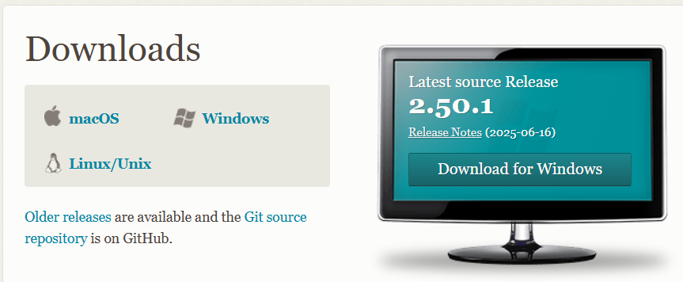

* Click on the **Windows** download link
* Save the .exe file

**Step 2: Install Git**

* Double-click the downloaded .exe file

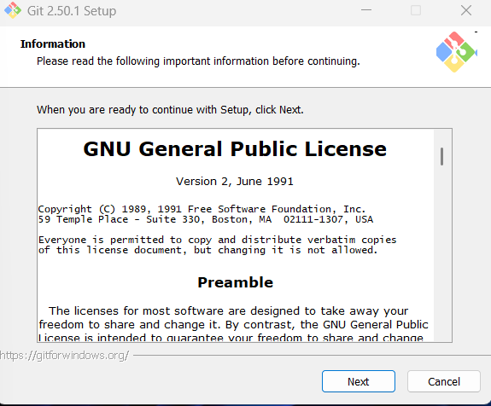

* Click **Next** through all setup screens. Accept default options unless needed otherwise:
  + **Editor**: Choose Notepad or leave default
  + **Path environment**: Select “Git from the command line and also from 3rd-party software”

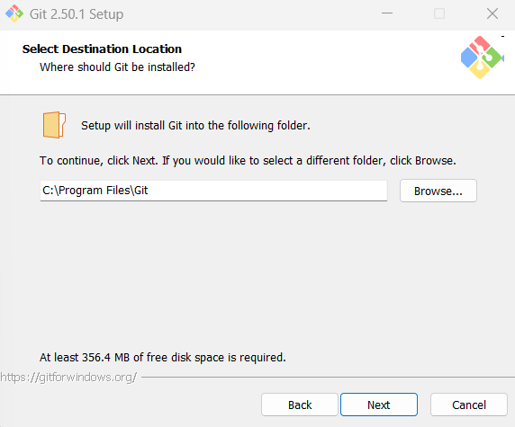

* + Leave other settings as default
* Click **Install**

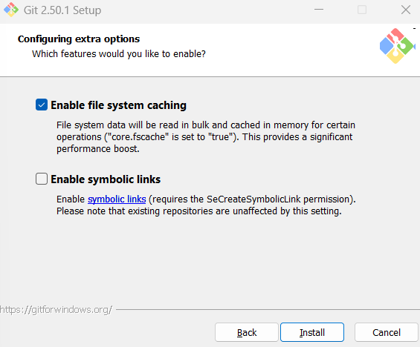

* After installation, click **Finish**

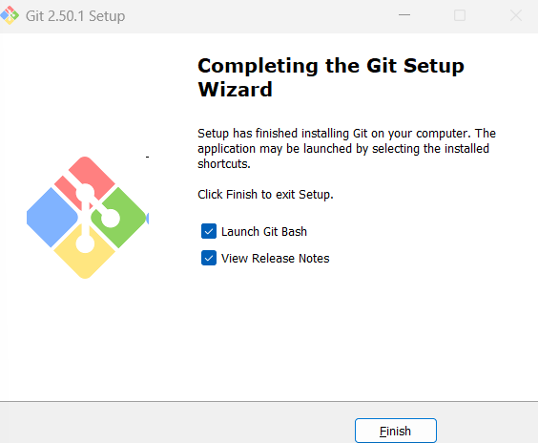

**Step 3: Open Git Bash**

* Go to **Start Menu** → Search **Git Bash**
* Open Git Bash (a terminal window will open)

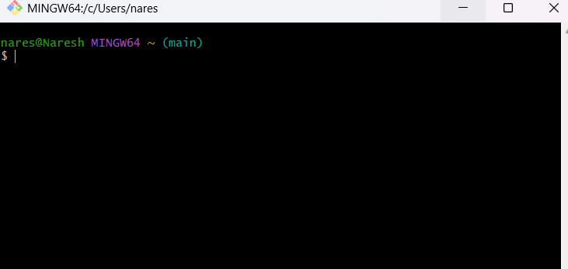

**Step 4: Verify Git Installation**

* In the Git Bash window, type:

